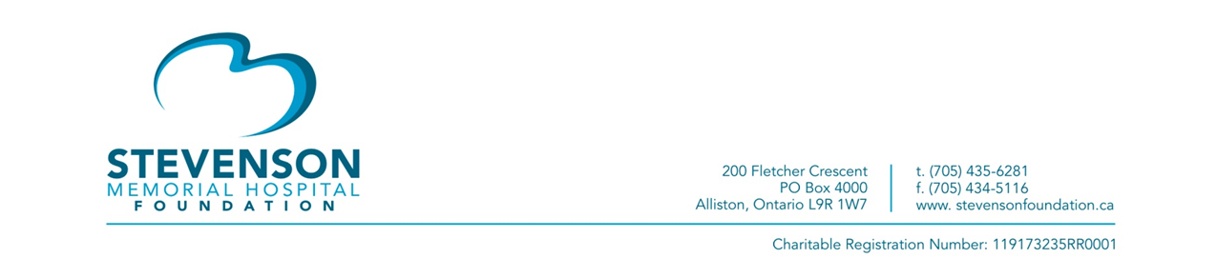
Stevenson Memorial Hospital Foundation to Host 2nd COVID-19 Virtual Q&A Event
[New Tecumseth, ON – June 9, 2020] – On Thursday, June 18 at 3 p.m., the community will have the opportunity to tune in to a second COVID-19 Q&A session featuring Stevenson Memorial Hospital (SMH) President & CEO, Jody Levac and SMH’s Chief of Obstetrics, Dr. Scheeres. The event is being hosted by the SMH Foundation (SMHF).
“We had a great response to our first virtual Q&A event,” says Tanya Wall, Executive Director, SMHF. “We are pleased to be able to host this second event, this time with a focus on SMH’s Obstetrics Department.”
The Q&A can be viewed by visiting the SMHF’s website at www.transformingstevenson.ca. The event will be recorded and available for viewing at a later time for those who cannot watch it on June 18.
Questions from the community are required to be submitted in advance to: foundation@smhosp.on.ca
The event is open to anyone in the community and is free of charge. Donations to the SMHF COVID-19 Pandemic Response Fund will be gratefully accepted and can be made by visiting their website.
The SMHF recently shared that as of May 1, The Morningview Foundation would match all donations up to $150,000 to the SMHF’s COVID-19 Pandemic Response Fund. This fund will cover costs such as equipment, supplies, and other priority needs as SMH fights this pandemic on the frontlines. Every gift made to the fund will be matched dollar for dollar.
Since making the matching gift announcement, $87,234 has been donated to the fund. “The matching gift from the Morningview Foundation has really inspired many people to contribute whatever they can,” says Wall. “SMH needs the support of the community now, more than ever. Seeing their donation amplified makes this an extra powerful time for donors to give. Every dollar really does count and we are so grateful to everyone for their support.”
Since launching COVID-19 Pandemic Response Fund in March, a total of $301,191 has been raised.

To make a gift to the COVID-19 Pandemic Response Fund and have your gift matched, please visit transformingstevenson.ca.
-30-
For more information:
Tanya Wall
Executive Director
Stevenson Memorial Hospital Foundation
twall@smhosp.on.ca
(705)-435-6281 ext. 3209

