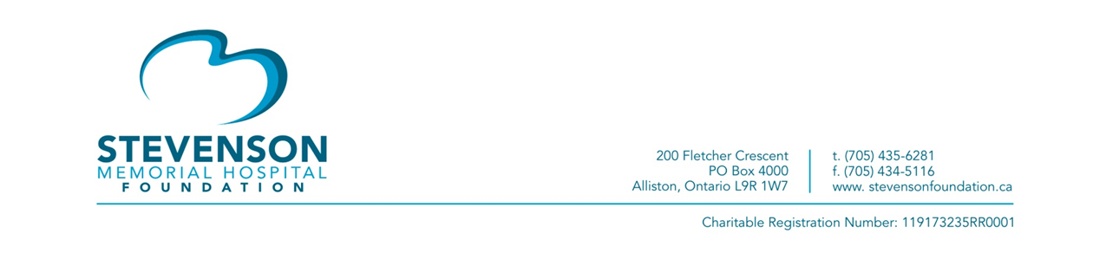
Help Us Redevelop SMH and Support the Revving Up for Revitalization Raffle
[New Tecumseth, ON – July 8, 2020] – Stevenson Memorial Hospital Foundation has launched the Revving Up for Revitalization Raffle, which will run from July 6th to August 31st in support of the redevelopment of Stevenson Memorial Hospital.
Ticket purchasers have the chance to win the grand prize of a 2019 Triumph Bobber Motorcycle or second prize of a Traeger Tailgater BBQ, both on display at Alliston Home Hardware Building Centre. A third prize gift basket from Beattie’s Distillers is also available to win. Tickets are $20 each and are available for sale at transformingstevenson.ca/motorcycle/. The winning tickets will be announced on September 1, 2020 at 10:30 AM at the hospital, and shared virtually.
GRAND PRIZE: Thank you to the Rizzardo Brothers (Previn Court Homes) for donating the grand prize of a red 2019 Triumph Bobber Motorcycle (value $14,500), including a 2-year unlimited KM factory Triumph warranty, and accessories as seen on the bike valued at $675.
Second prize is a Traeger Tailgater BBQ (value $599) donated by Alliston Home Hardware Building Centre and two Grilling Boxes from Country Meat Cuts (value $160).
Third prize winners will enjoy a cocktail for a cause with a gift basket from Beattie’s Distillers, perfect to complete any gourmet menu (value $150).
Ticket sales close on August 31st, 2020 at 11:59 PM EST and the draw will be held at 10:30 AM on September 1, 2020.
TRANSFORMING OUR SPACE. We began planning for the redevelopment of the hospital more than a decade ago. Today, we are making Stevenson Memorial Hospital’s transformative vision into a reality. The local share of the Redevelopment project is $30 million, and all of the proceeds from this raffle will help us get closer to reaching that target.
“Together with the support from the Rizzardos and our community partners, we’ve launched the Revving Up for Revitalization Raffle to help achieve our goal of new revitalized spaces that will reflect the exceptionally, high-quality health care SMH consistently provides. By purchasing raffle tickets, you not only have a chance to win some wonderful prizes, but you are helping us to transform health care right here in our community,” commented Tanya Wall, Executive Director, SMHF.
Please join us in becoming part of this new vision of health care for our community.
Lottery Licence Number /Numéro de la licence de loterie: 12034
-30-
For more information:
Melody McLean, CFRE
Director of Development
Stevenson Memorial Hospital Foundation
mmclean@smhosp.on.ca, (705) 435-6281 ext. 1263

